. 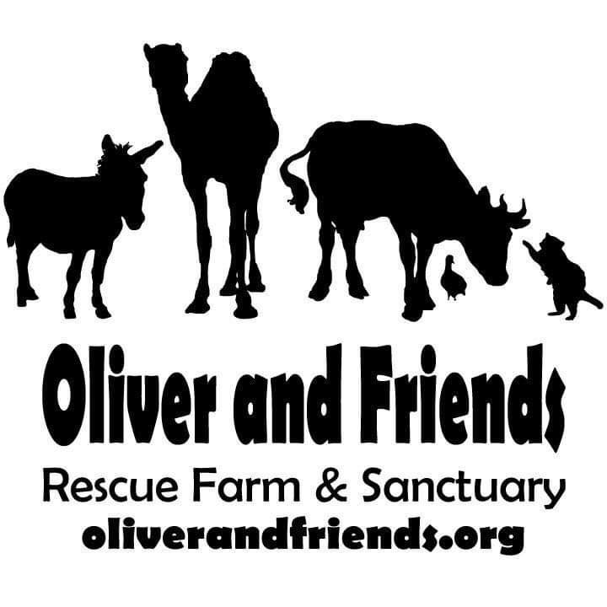

Home Adoption Application
This is an adoption application to bring a rescued animal to your home.

Thank you for your interest in adopting an animal rescued by Oliver and Friends Farm Sanctuary. Oliver and Friends wants to make certain every animal adopted goes to a loving home where the animal will be well cared for. Because of this, the application asks a number of questions which we hope you understand are necessary in our screening process. All information will be kept confidential, and if you have questions, please don't hesitate to call us at 405-655-9885​ ​or e-mail with a specific question to oliverandfriendsfarmsanctuary@gmail.com. Please allow 1 to 3 weeks for Oliver and Friends to process your application and to send notice of your application status. Any animal adopted from Oliver and Friends shall NEVER be rehomed or sold. If you are unable to keep the animal for any reason, he/she must be returned to the sanctuary.
All animals adopted out will be spayed/neutered, up to date on all age appropriate vaccinations, dewormed, and microchipped.
Please note appointments are necessary for adoption visits.​

*Required
Personal Information

- Name:
- Email:
- Street 1:
Street 2:

- City/State/ZIP:
- Phone Number:
- Date of Birth:

- Your employer:

- Number of children:

Youngest age:

Oldest age:

- Number of adults in household:

- Question - Are you:
Vegetarian __
Vegan __
Neither __

If no, please explain:

*Please list all animals currently living under your care:

- If adopting livestock​- If you do not currently have any farm animals, please list any experience you've had with them:

- If adopting livestock​ - Please describe your housing accommodations for farm animals:

*Please describe your fencing and pasture available for animals:

- Do you own the property where the animals will live? Yes __
No __

Veterinarian Information:
.
*Veterinarian's Name:

- Street 1:

- Street 2:

- City:

*State:

- Zip:

- Phone number with area code:

- If your animals should become ill, can you afford veterinary services?:
Yes __
No __

- Your household's annual income range:
$10-20,000 __
$20-35,000 __
$35-50,000 __
< $50,000 __

*Please list 3 personal references and their contact information. Personal references should not be people that are related to you:

1.)

2.)

3.)

- May Sanctuary Adoption Officers visit your home?:
Yes __
No __

*Please select the animal(s) you are applying to adopt: Please make between 1 and 9 selections from the choices below.

Cattle __
Pig __
Sheep __
Goat __
Dog __
Cat __
Rabbit __
Chicken __
Other Poultry __

Please note: Fees Due Upon Adoption
.
* By entering your initials below, you certify that you are over the age of 18 and all information is truthful to the best of your knowledge.

